Task 1

|  |  |  |
| --- | --- | --- |
| Pin 1 | Pin 2 | Output |
| 0 | 0 | 0 |
| 1 | 0 | 0 |
| 0 | 1 | 0 |
| 1 | 1 | 1 |

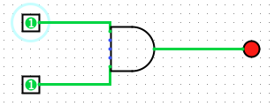

Task 2

|  |  |
| --- | --- |
| Pin | Output |
| 0 | 1 |
| 1 | 0 |

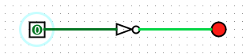

Task 3

|  |  |  |
| --- | --- | --- |
| Pin 1 | Pin 2 | Output |
| 0 | 0 | 1 |
| 0 | 1 | 1 |
| 1 | 0 | 1 |
| 1 | 1 | 0 |

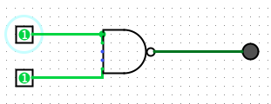

Task 4

|  |  |  |  |
| --- | --- | --- | --- |
| Input 1 | Input 2 | Sum Output | Carry Output |
| 0 | 0 | 0 | 0 |
| 0 | 1 | 1 | 0 |
| 1 | 0 | 1 | 0 |
| 1 | 1 | 0 | 1 |

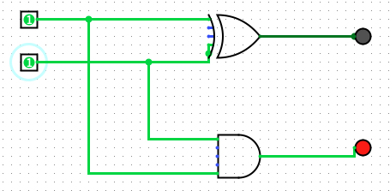

Task 5

|  |  |  |  |  |
| --- | --- | --- | --- | --- |
| Input 1 | Input 2 | Carry In | Sum Output | Carry Output |
| 0 | 0 | 0 | 0 | 0 |
| 0 | 1 | 0 | 1 | 0 |
| 1 | 0 | 0 | 1 | 0 |
| 1 | 1 | 0 | 0 | 1 |
| 0 | 0 | 1 | 1 | 0 |
| 0 | 1 | 1 | 0 | 1 |
| 1 | 0 | 1 | 1 | 0 |
| 1 | 1 | 1 | 1 | 1 |

